**Competition and Price Discrimination in the Colombian Air Market.**

Submitted by:

*Camilo Andrés Acosta Mejía Santiago Navas Gómez**Miguel González Albisser*

1. Introducción

Economic theory speaks of the relationship between competition and prices. It has been shown that the greater the number of suppliers, the lower the prices will be and that these will tend to reach the marginal cost of the producers. The airline industry is no stranger to this postulate; however, it is characterized by having few suppliers. Additionally, it should be considered that, for this industry, inventories are perishable, and demanders can buy the good in advance in different periods at different price levels. In this article, we examine the relationship between competition and price discrimination in the Colombian domestic air market, understanding how airlines or carriers discriminate prices intertemporally through indicators and establishing the current relationship in Colombia between such discrimination and competition.

The air transport market is complex and different from many more traditional markets. In traditional markets, inventories are stock, and it does not matter if they are stored for some time. However, inventory is immediately perishable in the airline market: an airline cannot sell a seat for a route after a plane covering that itinerary takes off. Since the moment a passenger buys a ticket reveals information about their willingness to pay and the price elasticity of demand, strategies such as price discrimination become essential in this type of industry, for which Revenue Management[1] techniques are used. According to Gatti Pinheiro et al. (2022), this practice allows efficient price discrimination, minimizing empty seats and maximizing revenue according to the information and algorithms available.

To understand this market, the costs that airlines must assume to provide their services must be considered. Parga (2001) explains that there are four determinants of airline costs in the country: payment to the labor factor (salaries), payment to the capital factor (leasing), fuel, and the exchange rate between the peso and the dollar, since most of the expenses incurred by these companies are in dollars, while their income is mainly generated in pesos. On the other hand, bidders incur high taxes and airport fees that must be paid, affecting the price offered to the final customer.

We propose a theoretical framework that explains a dynamic game that ends when the flight departs. In this game, the airlines participate in each period for each of the routes in which they are present. According to Bet (2021), a Nash-Bertrand equilibrium is the best way to solve it. However, we have found that the assumptions are violated since there is information asymmetry. The airlines do not know the competition's cost functions nor the final demand they will capture. Finally, the parameters of competition will be relevant in determining pricing strategies.

We use two sources of information: the Colombian Aerocivil monthly database for quantities and a web-scrapping[2] developed by a third party for prices between August 2021 and August 2022. From this information, we perform a two-stage least squares estimation (2SLS) to correct for potential endogeneity problems using as an instrument a difference-in-differences design where the treatment variable is the entry of Ultra Air in February 2022.

We find a positive effect on average in the long run, greater than 80 lags, where the effect of HHI on prices is significant for all observed routes. However, as the flight date approaches, the effect becomes non-significant. For the top 30 routes, we obtain results consistent with the previous ones, while when we take the remaining routes, the result changes, and in the long run, the effects of competition on prices cease to be significant. Additionally, when we only observe the leader of the routes, the average effect is insignificant in all lags, showing that for the leader, on average, the role of competition in its price determination is insignificant. On the other hand, we obtain that the followers consider changes in market concentration in their pricing strategies.

Price discrimination requires imperfect competition in the market (Stole, 2007; Purdy, 2021), which is the case, at least in the country's main routes (Nauffal, 2007). Likewise, economic theory generally shows that price discrimination generated by such competition generates losses in consumer welfare. However, price discrimination does not always generate an overall welfare loss in the economy, given the difference between consumers (Vélez-Velásquez, 2020; Garret et al., 2021). Consumers are heterogeneous in the market, and some are positively affected by their willingness to pay. In the airline market, we could find evidence of consumer differences in the corporate and tourism segments (Hazledine, 2011; Gerard & Shapiro, 2009).

We consider intertemporal price discrimination, which involves charging different prices at different periods (Barkley, 2019; Stokey, 1979). Bayer (2010) explains two pricing strategies: early-birds and last-minute buyers, showing that there are different strategies in the market to make intertemporal price discrimination. The following sections show how the airline industry often uses an early-birds strategy.

Also, we see different possible results when we review the literature on the relationship between price discrimination and competition in this market. According to Bayer (2010) and Hortaçsu, Williams & Oery (2022), there is a positive effect between competition and overall consumer welfare due to price reduction. On the other hand, Hazledine (2011) and Gerard & Shapiro (2009) state that the effects of competition on prices depend on market segments. Finally, Chakrabarty & Kutlu (2014) and Chandra and Lederman (2018) find an ambiguous relationship that depends on other variables.

In section 2, we present the literature review and the theoretical framework. Subsequently, in section 3, we present the data used and their respective descriptive statistics. Section 4 presents the methodology used and the econometric exercise. Section 5 presents our results from this exercise, and section 6 presents our conclusions.

1. Revisión de la Literatura y Marco Teórico
   1. Discriminación de precios.

According to Purdy (2021), price discrimination is the strategy of charging different prices for the same product or service to different types of consumers. On the other hand, stole (2007) explains that price discrimination exists when price variations between consumer segments are not explained solely by changes in marginal costs. In addition, for price discrimination to occur, a market must be in imperfect competition since, to be able to discriminate prices, a firm must have some market power. The extent of price discrimination in a market will depend on the ability and knowledge of firms to segment (Purdy, 2021).

It is common to speak of three types of price discrimination: first, second, and third-degree. First-degree, or perfect, discrimination is when the producer or seller can capture each consumer's maximum willingness to pay for the product (Stole, 2007). Second-degree discrimination is where producers offer a variety of menus (Stole, 2007); however, producers do so because they cannot observe the different types of consumers, so consumers self-select based on their characteristics and preferences. Finally, third-degree discrimination is where the producer segments based on specific observable characteristics of consumer groups (Purdy, 2021).

Vélez-Velásquez (2020) analyzes the case of the Colombian telecommunications market, where third-degree discrimination is applied. In this market, prices vary according to the consumer's income. The author measures the effect of discontinuing this practice and using a single fixed price for the entire population. He found that the companies' profit increases marginally, eliminating discrimination. At the same time, the welfare of the families varies depending on the region. In general, however, it is shown that welfare transfers were from lower-income families to those with higher incomes.

For the case of second-degree discrimination or nonlinear pricing, Garret et al. (2021) measure how consumers are affected when the market is regulated and exclude the discrimination in an imperfect competition model. In their study, the authors find that consumers with a high willingness to pay are affected by this measure. In contrast, those with a low willingness to pay benefits and make consumers' profit increase. However, firms' profit falls, causing utilitarian welfare to fall.

However, we examine the effects of intertemporal price discrimination. This type of discrimination consists of charging a different price in different periods where according to period t, the consumer will have a different willingness to pay (Barkley, 2019). An example of this is when a new cell phone goes on sale. The producer charges a relatively high price, P1. As time passes, the price decreases to capture more consumers, thus collecting a higher consumer surplus relative to a situation where a single price is set (Figure 1). However, this price fall is not necessarily entirely due to a price discrimination strategy; it may also be due to reductions in production costs, among other factors (Stokey, 1979).

Figure 1. Example of intertemporal price discriminationForma, Rectángulo

Descripción generada automáticamente

Taken from: Barkley (2019).

On the other hand, Bayer (2010) mentions two different intertemporal price discrimination strategies. The first scenario is the last-minute strategy, where consumers can check the price in advance at the end of the anticipation curve. Prices decrease to sell those products. Conversely, the author explains the opposite case in which there is an early-birds strategy where consumers who want a lower price will start looking for such products earlier in anticipation of lower prices. Figure 2 shows how the Bogota-Medellin route (BOGMDE) behaves as an early-birds strategy, in which, as time passes and reduces the inventory, there are fewer and fewer seats available on the plane, but the price continues to increase.

Figure 2. Intertemporal price discrimination, anticipation to flight date.

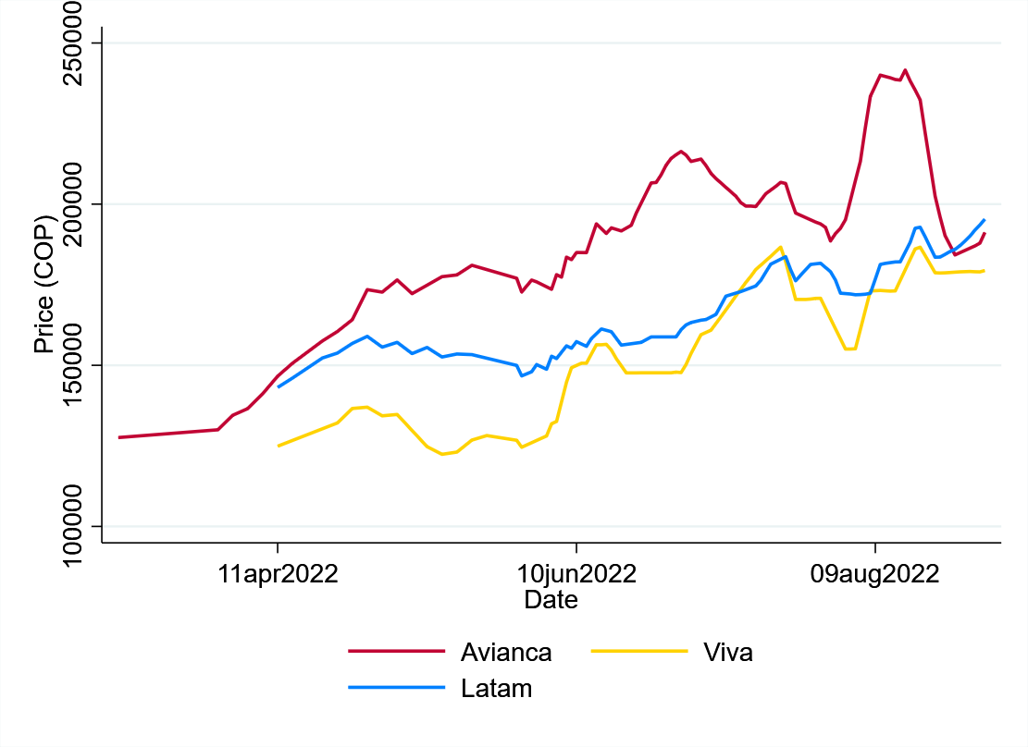

Taken from: Third party web scrapping (2022), own calculations.

Intertemporal price discrimination is a type of discrimination observable in the airline industry worldwide and the Colombian market, given that it is a perishable inventory on the flight date (Hortaçsu, Williams & Oery, 2022). As observed in Figure 2, the prices vary according to the anticipation of the flight, considering that these inventories are perishable and not stocked as in the previous example of Barkley (2019).

* 1. Competition and prices relatioship

According to theory, there is an inverse relationship between the number of suppliers and price. The airline industry is no stranger to this postulate. According to Morrison & Winston (1990) and Gerard & Shapiro (2009), the best strategy to reduce ticket fares is usually to encourage competition and allow the entry of new companies. The airport slots limit the effect by not allowing competition to grow significantly, being a barrier to entry for new suppliers (Morrison & Winston, 1990).

Bet (2021) finds that in the U.S. market, concentration and deregulation tend to increase by 15% the markup of companies during the 1990s. However, the trend has changed in recent years, and IATA (2022) forecasts losses of 9.7 billion dollars by 2022 by reducing airline markup.

Bayer (2010) finds that the effects of competition and price discrimination on consumer welfare are positive but not as high as expected, given the economic theory for perishable goods. Similarly, Hortaçsu, Williams & Oery (2022) find that, through demand estimation and characterization of equilibria, price discrimination in the airline market increases firms' profits and reduces overall welfare. In addition, Hazledine (2011) and Hortaçsu, Williams & Oery (2022) find that demand changes over time, and firms profit from such changes by having consumers reveal their willingness to pay and allowing firms to price discriminate intertemporally.

On the other hand, Hazledine (2011) mentions that there are different consumer segments in the market and that the effect of discrimination is different for each of them. Consumers with more inelastic demand are not significantly affected by this discrimination. However, consumers whose demand is more elastic are negatively affected. Gerard & Shapiro (2009) explains that the price dispersion is higher when the market is competitive for the corporate segment whose willingness to pay is higher. However, when the market is competitive, and the predominant segment is more price sensitive and less willing to pay, it reduces the price dispersion.

Chakrabarty & Kutlu (2014) allow for a nonlinear relationship between price dispersion and competition and find an S-shaped behavior that explains why in the literature, there is some ambiguity between this relationship. Chandra & Lederman (2018) analyze various fares or classes in a flight and find a U-shaped relationship between price and competition. In other words, market segments positioned at the top and the lower end are affected, while the average consumer is not affected. Then, greater competition does not necessarily mean an improvement in consumer welfare. Stavins (2001) finds that airlines with a larger market share can price discriminate more efficiently.

In addition, price dynamics are determined by changes in own-product opportunity costs and demand and by competitors' inventories as they affect future prices. Chandra & Lederman (2018) present a current discussion in the literature between prices and competition in the airline market, mentioning that higher competition does not always result in lower prices, given the different market segments and other variables such as loyalty programs.

* 1. Theorical frame work

Within the Colombian airline industry, each flight represents a dynamic game that ends when the flight takes off, forcing airlines to have a multi-period game on each route[3]. The airline offers a price in each period, but this must consider the type of demand it faces, the competitor's strategy, and the behavior expectations of the route. Therefore, prices may reflect the evolution of opportunity costs, where the cost of selling a unit today depends on the ability or expectation of being able to sell it in the future at a higher price (Hazledine, 2011; Hortaçsu, Williams & Oery, 2022).

We argue that the lack of knowledge of competitors' cost functions and the heterogeneity of demand on each route[4] prevents airlines from having clear information at the beginning of the game about the type of demand they face and the strategies of their competitors. Making behavioral parameters more relevant, which tend to be stable over time, but different across routes.

As the end game develops and approaches, airlines become increasingly aware of their competitors' strategies. Individuals become more homogeneous (as those with higher price elasticity of demand have already purchased their tickets). Route expectations become more precise and less relevant. In the long run, in-route competition parameters will be more relevant for airlines as they tend to be more stable. As the day of the flight approaches, they will begin to segment better the demand they face and the strategies of their competitors. It allows them to have more and more weight at the time of deciding on the price to be offered.

The market structure is Bertrand-type (Bet, 2021). However, these market structures must satisfy homogeneous prices, which implies no capacity restrictions, known total competition costs, and equal marginal costs. Therefore, within a Bertrand-type structure, equilibrium will occur when the price is equal to the marginal cost. For the Colombian case, we observe that heterogeneous prices exist because the market violates the abovementioned assumptions. Allowing price competition, but these are associated with opportunity costs, forcing the definition of short- and long-term strategies that are affected by future market behavior.

In Figure 1.A.8, we find that routes with higher demand have higher occupancy levels and more consumer segments (Hazledine, 2011 and Gerard & Shapiro, 2009), possibly more demanded routes be different strategies from routes with lower demand.

On the other hand, Hortaçsu, Williams & Oery (2022) mention that there are differentiated strategies between leaders and followers which they call companies with excess and shortage of inventories, respectively. For example, a firm with an inventory shortage may lower prices to increase future equilibrium prices. Alternatively, a firm with excess inventories may raise prices so that others will sell everything sooner instead of lowering prices and reducing its inventory excess.

1. Data and Background
   1. The colombian case

The airline industry's growth in recent decades has increasingly allowed us to connect with other cities and countries, overcome geographical barriers, and boost global economic growth (Tian et al., 2021). Florida (2017) states that city pairs with at least one weekly direct connection have, on average, significantly greater business connections than those city pairs without such a connection.

The airline industry is sensitive to conjunctural and regulatory changes, and the Colombian case is no exception. According to Olariaga (2016), from the 1990s, we can observe changes in domestic market dynamics. As shown in Figure 3, between January 2011 and January 2022, the number of passengers went from 1.4 million to 2.8 million people, while the number of seats offered went from 1.7 million to 3.3 million in the same period. The growth of passengers flown was approximately 118% in 11 years (Figure 1). Additionally, the occupancy factor (seats flown over seats offered) increased from 83% to 85% (Aerocivil, 2022), showing that demand has grown faster than supply. In other words, in January 2022, the equivalent of approximately 6% of the Colombian population made a domestic flight in the country, positioning the industry as an essential subsector in the national economy and becoming one of the most important in the region.

Figure 3. Seats offered and passengers flown between 2011 and 2022 per month.

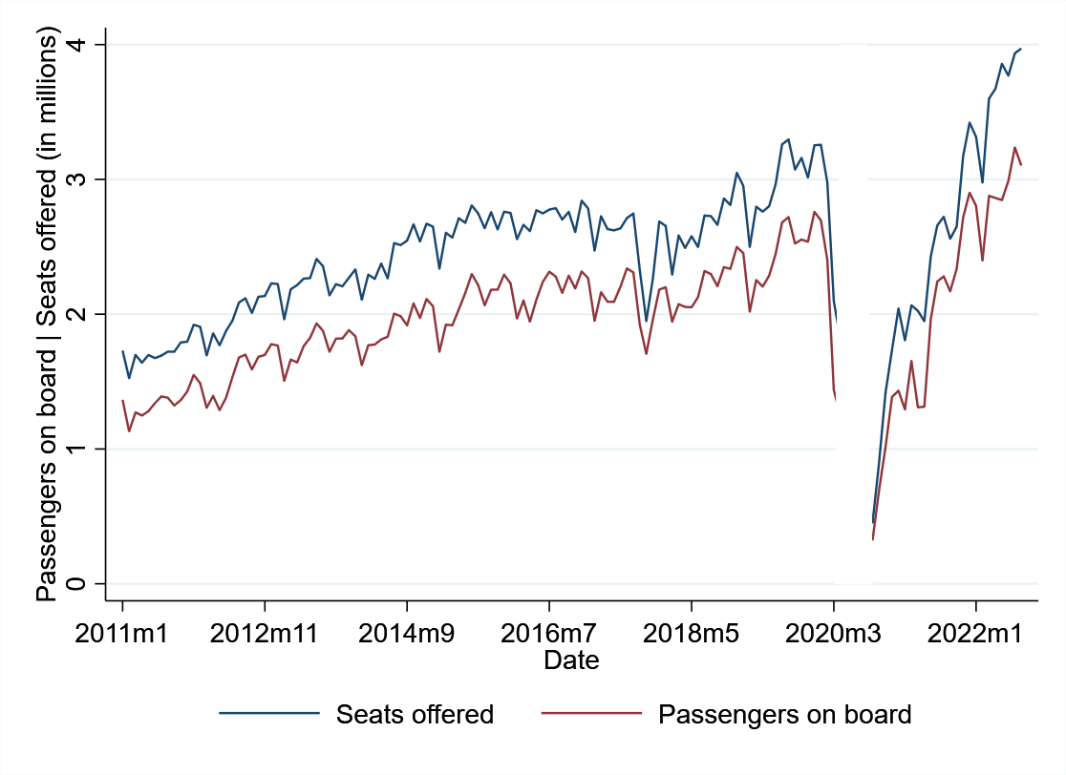

Fuente: Construcción propia, Aerocivil (2022)

In Figure 3, we show how the industry can be affected by different events. For example, what happened in 2017, when the pilots of the company with the largest market share, Avianca (Figures 3 and 4), went on strike during September and October, decreasing the number of chairs offered from 2.8 million in August to 1.9 million in October. Then, in 2020 with the arrival of COVID-19, the sector was quite affected, reaching some months to fly and offer the equivalent of 0 seats nationwide. After this, we can observe that the industry recovered, achieving the dynamism that characterizes it and having more passengers and seats offered.

In Colombia, only some companies participate in this market, and there is a certain degree of competition. Therefore, we can categorize this industry as an example of oligopolistic competition. According to Nauffal (2007, p.5), companies' decisions for the market are price rather than quantity, which indicates that the functioning of the country's air market is closer to a Bertrand-type oligopoly in which product differentiation and competition among suppliers is via prices. Camacho (2015) explains how the two leading airlines providing air transport services in the national territory (Avianca and Latam) together represent about 70% of the market (Figure 4). However, the author explains that as new competitors have entered the market, the so-called low-cost carriers (LCC), notably Viva Air-the market concentration, have decreased. Viva Air has captured a significant market share through solid price competition. As mentioned by Tian et al. (2021), the airline industry is facing a complex and dynamic environment due to the emergence of these LCCs.

Figura 4. Cuota de mercado principales aerolíneas desde 2011 a 2022.

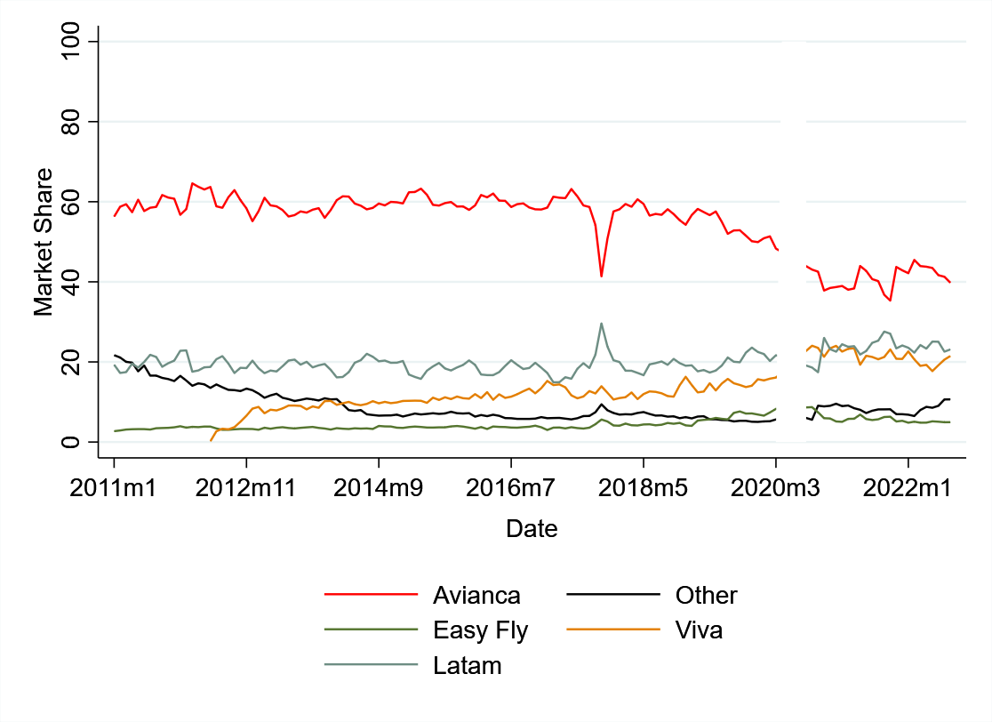

Tomado de: Aerocivil (2022), cálculos propios

* 1. Data

We use two sources of information to study the relationship between competition and intertemporal price discrimination. First, we use quantity data from the market regulator, the Aerocivil, subject to the Colombian Ministry of Transport. These data are reported monthly at the route, airline, and market level, including the type of traffic, type of flight, number of flights made, number of passengers flown, number of seats offered, and distance. From this data source, we collected historical information from January 2011 to August 2022, equivalent to 457,419 observations.

For prices, we resorted to a computational practice called web scrapping developed by a third party. The company captures minimum prices of flights on specific routes up to a maximum horizon of 150 days into the future for each airline. For example, we capture all Latam flights for the CLOCTG route (Cali-Cartagena) from that day, capture up to 150 days into the future, and repeat this process daily. Therefore, we obtain the behavior of the minimum price of the route over time with different periods of anticipation. It also allows us to obtain data at the date, route, and flight number level and includes information on the net price, gross price, and taxes charged for these specifications. We collect this information from August 21, 2021, through September 30, 2022, with approximately 768 million observations.

For our competition's measure, we use its inverse, market concentration, using the HHI at the route level, widely used in the literature as a proxy for the absence of competition in a market. We captured information for 94 routes over a flight period from November 2021 to August 2022. However, the pricing information is from August 2021 to August 2022. On the other hand, we observe eight airlines: Avianca, Latam, Viva, Easy fly, Wingo, Satena and GCA, and Ultra Air.

For this exercise, we considered the effects of the largest airlines in the market. Therefore, we use only routes with more than one supplier to observe the effects of competition on price discrimination, going from 94 to 74 routes. Additionally, they report quantity data monthly and price data daily. Therefore, we decided to group the latter to merge the information sources. We change the price data format where we observe for a given month, route, and airline the average price in k past periods.

* 1. Statistics

Table 1 shows the main descriptive statistics of the variables that refer to quantities. Observation refers to a route, in a specific month and a carrier, for example, all flights operated by Avianca in December 2021 for the BOGCLO route (Bogota-Cali). For the variable flights, we found 2066 records where there is at least one route in which an airline operates only one flight per month and a maximum of 592, with an average of 87.4 flights per carrier per monthly route. Additionally, this variable has a standard deviation of 99.

  Table 1. Statistics

|  |  |  |  |  |  |  |
| --- | --- | --- | --- | --- | --- | --- |
|  |  |  |  |  |  |  |
| **Variable** | **Obs** | **Media** | **Mediana** | **Min** | **Max** | **Sd** |
| Flights | 2066 | 87,428 | 53 | 1 | 592 | 98,779 |
| Passengers | 2066 | 12073,7 | 6936 | 72 | 90477 | 14258,56 |
| Seats offered | 2066 | 14867,8 | 8820 | 140 | 98156 | 16981,13 |
| Occupancy factor | 2066 | 80% | 82% | 19% | 99% | 0,106 |
| Market share | 2066 | 33% | 29% | 1% | 100% | 0,218 |
| HHI[5] | 836 | 0,438 | 0,428 | 0,257 | 1 | 0,126 |
| Airlines Per route | 74[6] | 3 | 3 | 2 | 6 | 1 |

On the other hand, the variable passengers flown are those who boarded the plane and flew to the destination; we have 2066 records. This variable has a minimum value of 72 passengers, a mean of 12,074 passengers, a maximum value of 90477, and a standard deviation of 14258,6. Likewise, the variable of seats offered has 2066 records, with a minimum value of 140, a mean of 14867.8 seats, a maximum value of 98156 chairs, and a standard deviation of 16891,13.

Additionally, we calculated the occupancy factor as the ratio between passengers flown and seats offered. This variable also has 2066 observations. The mean is 80%, with a standard deviation of 0.106. It also has a minimum value of 19% and a maximum value of 99%. Market share has 2066 observations, a mean of 33%, a standard deviation of 0.218, a minimum value of 1%, and a maximum value of 100%. However, as defined in section 3.C, we only consider routes with two or more suppliers.

HHI is at the route and month level, with 836 records. This index has a minimum value of 0.26, a maximum value of 1, a mean of 0.43, and a standard deviation of 0.126. The airlines per route show the behavior of the number of suppliers per route.

Given the size and number of variables considered for the prices, we decided to show some graphs for three different scenarios. Figure 5.a shows the average behavior of the price variable over time for the 30 primary routes in the country. Figure 5.b shows the behavior of average prices over time for the routes in the top 30 and top 60 routes. Finally, Figure 5.c shows average prices over time for the remaining routes. These average prices do not include a specific Carrier but are the average for a given lead time.

Figure 5. Price Statistics

Figure 5.a Top 30 routes

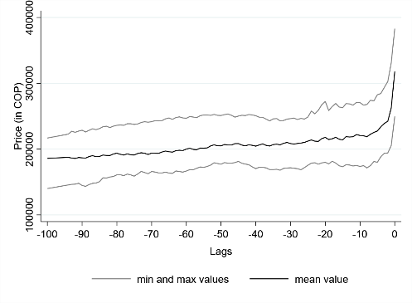

Figure 5.b Routes from 30 to 60

Figura 5.c Routes 60+

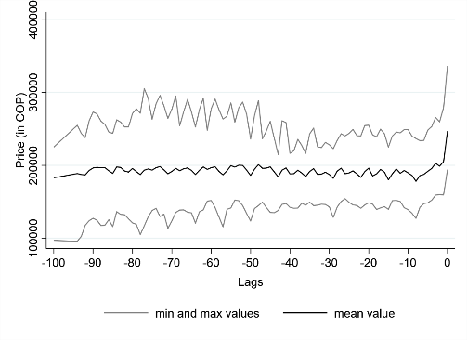

Source: Third party web scrapping (2022), own calculations.

In the empirical strategy, we use two-panel data sources. The first one contains information on the price and quantity behavior of the airlines mentioned above within 74 domestic routes in Colombia. We can observe the heterogeneity of prices of each airline on the route. The second also contains information on prices and quantities. However, this only considers the route, and the prices are a weighted average where the market shares give the weights during the entire period analyzed of an airline on a specific route. [7]

1. Empirical strategy

We empirically validate the behavior of firms through changes in market concentration. According to what we posed in section 2.C, we can estimate a model using the following functional form as the principal equation:

represents the natural logarithm of price in a period *t-k*, is the HHI, and are route and airline fixed effects, respectively. *k* takes values between 0 and 150, i.e., considering prices up to 150 days before a flight. In addition, as a secondary equation, we use the following functional form:

The most crucial difference between both functional forms is the subscript j representing the airline. In the first one, we observe the price offered by each airline within a route at a time t-k and corresponding to a period m, allowing us a deeper analysis and capturing more heterogeneity. However, in the second functional form, we omit this sub-index since we wish to measure a route-level effect and create a weighted average of the price on each route.

Identifying causal effects is not straightforward, as an endogeneity problem arises from the simultaneity between quantities and prices (Chandra & Lederman, 2018). Therefore, estimating this relationship without considering such an effect would produce biased estimators whose statistical inference would be invalid. We use a two-stage least squares estimation (2SLS) with the fixed effects model. We instrument for market concentration using Ultra Air's entry into the Colombian airline market in February 2022.

Ultra Air started operations in February 2022. It currently has 6 A320 aircraft with 180 seats each and has a hub in Rionegro, Antioquia, serving the city of Medellin, Colombia's second-largest city. It currently operates 34 routes to 10 destinations and has 100 weekly frequencies [8]. In other words, it has a maximum capacity to transport 18,000 passengers per week and only operates domestic flights in Colombia. This airline has an initial investment of US$30 million and 22,000 direct, indirect, and induced jobs (Ultra Air, 2022).

For the first stage, we used a 2x2 Difference-in-Differences design. This type of design has two advantages. The first is associated with the randomization of the treatment as it allows the treatment to be non-randomized, and the second allows for unobserved heterogeneity to provide a credible estimate of the average treatment effect on the treated (ATT). The treatment variable is Ultra Air's entry into the market, and the treated will be those routes where Ultra Air has had a presence since its operations began[9]. We specify the functional form of the first stage as:

is the natural logarithm of the HHI, *PUA* is a binary type variable equal to 1 if the observation is on a route with Ultra Air presence, and *EUA* is a binary type equal to 1 if the observation is in a period after February. Finally, the variables *R* and *C* are fixed effects of route and airline, respectively. The F-statistic value of the first stage is greater than 100, which allows us to affirm that the instrument is sufficiently strong (Lee, McCrary, Moreira, and Porter, 2022).

The value of the coefficient makes economic sense since the entry of Ultra Air reduces market concentration on the routes where the airline participates.[10] We find that, on average, the entry of Ultra Air reduces the HHI by 1400 points relative to the routes it does not enter. However, any difference-in-differences design must comply with the parallel trend assumption, assuming no route-specific unobservable variables over time. That is equivalent to assuming that the temporal change is the same for all units. If this is satisfied, we can identify the causal effect and have a sufficiently strong instrument.

To validate that the data satisfies this assumption, we use two methods. The first is a graphical approach where we compare the means of the HHI in the treated and untreated routes before and after treatment (Figure 6.a). The second is the pre- and post-treatment effect through an event study design (Figure 6.b). For the first method, there are parallel trends between the groups, and only essential changes in the treatment group after the treatment. For the second method, we found similar results since, prior to treatment, no coefficient was statistically different from zero. That allows us to affirm that the assumption of parallel trends is satisfied.

Figure 6. Parallel trend assumption

6.a Graphical approach

6.b Empirical approach

1. Resultados

In Figure 7, we present the main results of the functional forms proposed in section 4, where each point represents the effect of the logarithm of the HHI index on the price level in the corresponding lag, which allows observing trend behaviors of the effect. Figures 7.a and 7.b show the primary and secondary equation results using 2SLS with route-fixed effects. Both results are similar in terms of trends and how the estimations behave. They align with what we propose in section 2.C and what is proposed in the literature since increases in market concentration positively affect the price level.[11] However, the first stage F-statistic for Figure 7.a is 182.9, and that of Figure 7.b is 49.1. It shows that the instrument is more robust in regressions using more disaggregated data.

Figure 7. Overall results

7.a Principal Regression with FE route

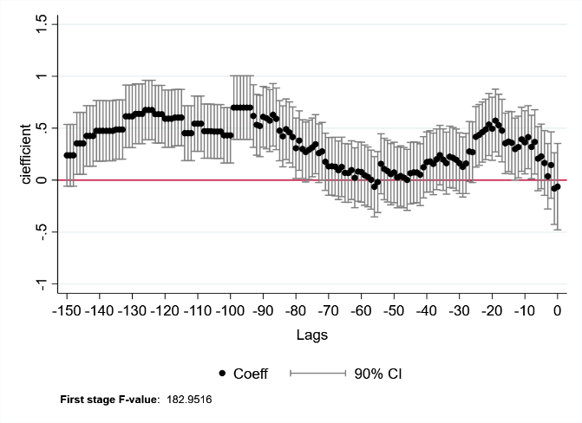

7.b Secondary Regression with FE route

The principal and second regression results present a similar trend in which lagged t greater than 80 positively affects market concentration and price level. We show that airlines have greater power over prices as their HHI increases in these periods and becomes non-significant at 90% confidence as the flight approaches. However, the principal regression between days 25 and 10 has a positive effect, with a smaller magnitude than those mentioned above. For example, on average, a 1% increase in the HHI increases the price by 0.35%, so, according to economic theory, there is a positive relationship between market concentration and price level.

As we stated in section 2.C, each airline has a different strategy and must adapt its strategy to each route in which it has a presence. Figure 8 shows the results of the principal regression for different groups of routes[12] and in Figure 9 for both leaders and followers. Figure 8.a refers to the top 30 routes, and Figure 8.b to the remaining routes. Both results are similar to those obtained in the previous regressions. However, Figure 8.b shows that the effect is initially not significant and is determined to a lesser extent than in Figure 8.a. This difference in the effect is attributed to the size of the demand in this group, allowing us to validate that there is heterogeneity among routes. This heterogeneity Forces airlines to create strategies for these, according to section 2.C and as evidenced in Figure 1.A.8, where discrimination patterns vary subject to demand patterns.

Figure 8. Results by route groups with FE route

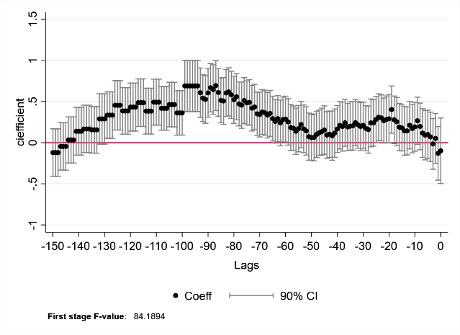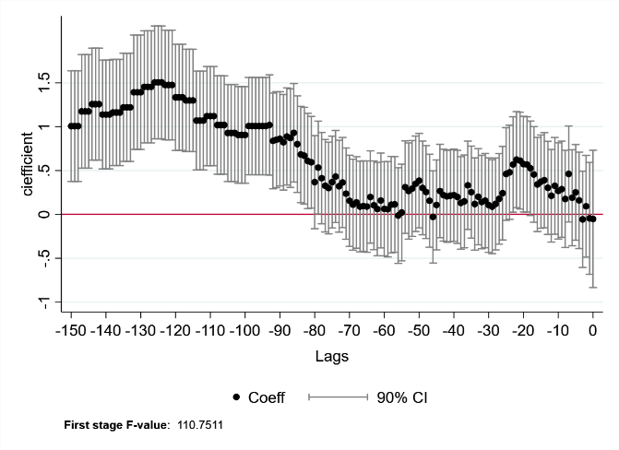8.a The top 30 routes 8.b The 30+ routes

In Figure 9.a, we show that market concentration is not relevant for a leader on average when determining prices. That is because by holding the position of leader in that market, other factors take precedence when making pricing decisions, as explained in section 2.C. However, a follower, on average, tends to increase its prices in the face of increases in market concentration since it allows them to make better price discrimination and capture different consumer segments. This result goes hand in hand with Hazledine (2011), where followers, given their scarcity of inventories, seek to increase their prices so that the leader fills up first with consumers with lower willingness to pay, and followers capture passengers with higher willingness to pay.

Figura 9. Leaders and followers Results with route FE

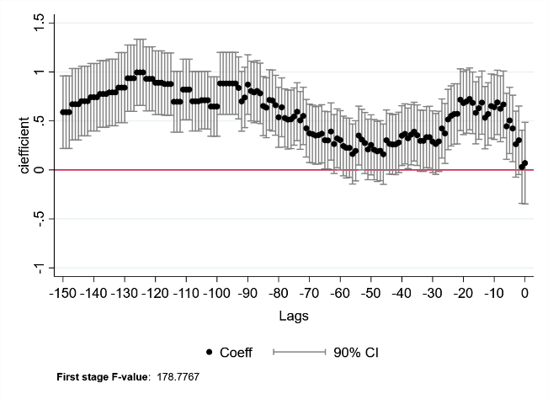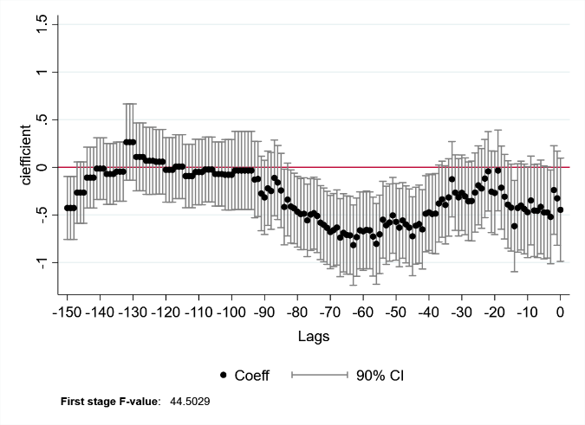9.a Leaders Results 9.b Followers Results

1. Conclusion

This paper presents the effects of competition on intertemporal price discrimination in the Colombian domestic airline market. We postulate a dynamic game where airlines participate in each period through the price level, approximating a Bertrand-type structure (Bet, 2021). However, we find that violates the assumptions since there is information asymmetry; airlines need to know the cost functions of the competition and the final demand they will capture, making competition parameters relevant to determine pricing strategies.

For this, we propose a model where the independent variable is an index of market concentration, and the dependent variable is associated with the price level. However, since there is an endogeneity problem, the model is estimated through two-stage least squares. Our instrument is a 2x2 difference-in-differences design, which we use as a treatment variable for the entry of the airline Ultra Air into the market in February 2022.

On average, for the industry, increases in route concentration tend to lead to price increases relevant to the effect that competition parameters have on the strategies employed by airlines when determining prices. This behavior is similar for the case of the top 30 routes, but for the remaining 44 routes, the effect is usually more minor and not significant in the farthest lags. Finally, we find that in the case of the leaders, it is not relevant to incorporate market concentration in their pricing strategies because other factors are more critical in their pricing decisions. On the other hand, in the case of followers, we found that they tend to increase their prices in response to increases in market concentration since it allows them to make better intertemporal discrimination and capture different consumer segments.

We contributed to the literature by testing the effects that competition parameters may have on the pricing strategies implemented by airlines, for the case of the Colombian domestic airline market, between August 2021 and August 2022. Given the results obtained, we conclude that the parameters are relevant for such strategies, finding a direct relationship between concentration and price level; however, they cease to be relevant two and a half months before the flight, on average.

1. Bibliografía

Aerocivil. (2022). Estadísticas operacionales. <https://www.aerocivil.gov.co/atencion/estadisticas-de-las-actividades-aeronauticas/estadisticas-operacionales>

Barkley, A. (2019). The economics of food and agricultural markets. *New Prairie Press*.

Bayer, R. C. (2010). Intertemporal price discrimination and competition. *Journal of Economic Behavior and Organization*, 73(2), 273–293.

Bet, G. (2021). Market Power in the US Airline Industry. *SSRN 3913695*.

Camacho Serrano, M. C. (2015). La lucha por la participación del mercado en el negocio aeronáutico en Colombia entre Avianca y LAN vista desde una perspectiva evolutiva Master's thesis, Bogotá-Uniandes.

Chakrabarty, D., & Kutlu, L. (2014). Competition and price dispersion in the airline markets. *Applied Economics*, 46(28), 3421-3436.

Chandra, A., & Lederman, M. (2018). Revisiting the relationship between competition and price discrimination. *American Economic Journal: Microeconomics, 10*(2), 190-224.

Florida, R. (2022). Bloomberg. How Direct Flights Shape a City's Fortunes <https://www.bloomberg.com/news/articles/2017-10-31/the-economic-power-of-direct-flights>

Garrett, D., Gomes, R., & Maestri, L. (2021). Oligopoly under incomplete information: on the welfare effects of price discrimination. *International Journal of Industrial Organization*, 79, 102735.

Gatti Pinheiro, G., Defoin-Platel, M., & Regin, J. C. (2022). Outsmarting Human Design in Airline Revenue Management. *Algorithms*, 15(5), 142. <https://doi.org/10.3390/a15050142>

Gerardi, K. S., & Shapiro, A. H. (2009). Does competition reduce price dispersion? New evidence from the airline industry. *Journal of Political Economy*, *117*(1), 1-37.

Goodman-Bacon, A. (2021). Difference-in-differences with variation in treatment timing. *Journal of Econometrics*, *225*(2), 254-277.

Hazledine, T. (2011). Price discrimination in Australasian air travel markets.  *New Zealand Economic Papers*, *45*(3), 311-324.

Hortaçsu, A., Öry, A., & Williams, K. R. (2022). Dynamic Price Competition: Theory and Evidence from Airline Markets, NBER Working Paper.

IATA. (2022). Travel Recovery Rebuilding Airline Profitability - Resilient Industry Cuts Losses to $9.7 billion. <https://www.iata.org/en/pressroom/2022-releases/2022-06-20-02/>

Lee, D. S., McCrary, J., Moreira, M. J., & Porter, J. (2022). Valid t-ratio Inference for IV. *American Economic Review*, *112*(10), 3260-90.

Morrison, S. A., & Winston, C. (1990). The dynamics of airline pricing and competition. *The American Economic Review, 80(2)*, 389-393.

Nauffal Monsalve, S. (2007). Organización industrial y competencia estratégica de las aerolíneas en Colombia, *Bachelor's thesis, Facultad de Ciencias Económicas y Administrativas*.

Olariaga, O. D. (2016). Análisis del desarrollo reciente del transporte aéreo en Colombia*. Revista transporte y territorio*, (14), 122-143.

Parga, X. P. (2001). ¿Qué tan poderosas son las aerolíneas colombianas?: estimación de poder de mercado en las rutas nacionales. *Departamento Nacional de Planeación*.

Purdy, E. R. (2021). Price Discrimination. *Salem Press Encyclopedia*.

Stavins, J. (2001). Price Discrimination in the Airline Market: The Effect of Market Concentration. *The Review of Economics and Statistics*, *83*(1), 200–202.

Stokey, N. L. (1979). Intertemporal Price Discrimination. *The Quarterly Journal of Economics*, 93(3), 355–371

Stole, L. (2022). ORGANIZATION Handbook of Industrial Organization, 3rd ed., pp. 2233-2286. *North-Holland*.

Tian, H., Presa-Reyes, M., Tao, Y., Wang, T., Pouyanfar, S., Miguel, A., ... & Iyengar, S. S. (2021). Data analytics for air travel data: a survey and new perspectives. *ACM Computing Surveys (CSUR), 54(8)*, 1-35. <https://doi.org/10.1145/3469028>

Ultra Air (2022) Acerca de Nosotros. Tomado el 24 de octubre del 2022 de: <https://www.ultraair.com/home/search>

Vélez-Velásquez, J. S. (2020). Banning Price Discrimination under Imperfect Competition: Evidence from Colombia's Broadband. *Borradores de Economía*; No. 1148.

Williams, K. R. (2022). The welfare effects of dynamic pricing: Evidence from airline markets. *Econometrica*, 90(2), 831-858.

1. Apéndice
   * 1. 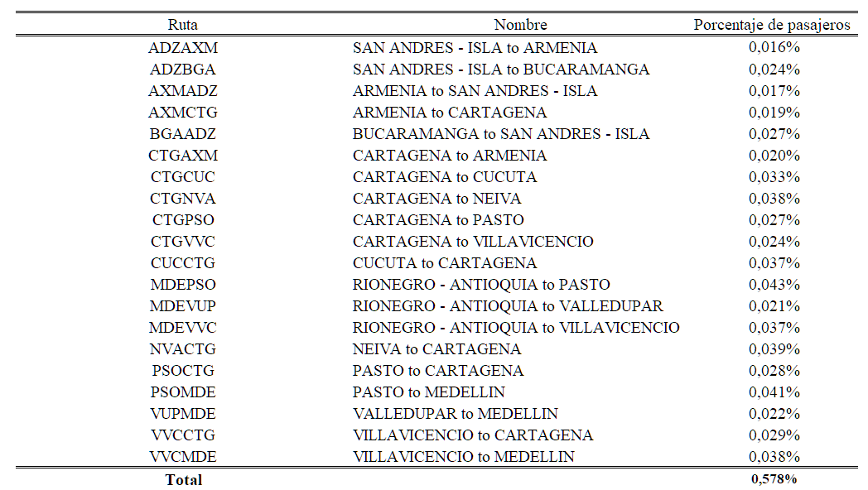Rutas donde solo existe un oferente
     2. Diseño de diferencias en diferencias

La variable de tratamiento será la entrada de Ultra Air al mercado la cual se denomina *T*, y los tratados serán aquellas rutas donde Ultra Air tiene presencia desde que inicia operaciones. Por otro lado, se tiene un grupo de no tratados o control que se denotará como *U* el cual está representado por aquellas rutas donde Ultra Air no tiene presencia aún, así:

Donde es el ATT estimado para el de tratamiento *T*, y es la media de la muestra para cada grupo en concreto en un periodo determinado. Si se expresa la ecuación anterior como una expectativa condicional se tiene:

Si se agrega y se reescribe la ecuación anterior se puede obtener una descomposición en términos de resultados potenciales condicionados:

Donde el primer componente de la ecuación es el ATT y el segundo es algo conocido como *non-parallel trends bias in 2x2 case*, el cual está asociado al supuesto más importante del diseño de diferencias en diferencias llamado supuesto de tendencias paralelas. Puesto que si este supuesto se cumple el diseño podrá identificar el supuesto causal y se tendrá un instrumento lo suficientemente fuerte.

|  |  |  |
| --- | --- | --- |
|  |  |  |
|  | *Pre* | *Post* |
| Tratados | Grupo de tratamiento previo a la entrada de Ultra Air al mercado [] | Grupo de tratamiento posterior a la entrada de Ultra Air al mercado  [] |
| No tratados | Grupo de control previo a la entrada de Ultra Air al mercado [] | Grupo de control posterior a la entrada de Ultra Air al mercado [] |

* + 1. Grupos de Control y tratamiento para el diseño de Diferencias en Diferencias
    2. Resultados promedio de la primera etapa con Efectos fijos de Ruta y mes

|  |  |  |  |  |  |  |
| --- | --- | --- | --- | --- | --- | --- |
|  |  |  |  |  |  |  |
|  | **Coefficient** | **Standard Deviation** | **t-value** | **p-value** | **Lower Bound** | **Upper Bound** |
| Ultra-Air Effect | *-0,140* | *0,010* | *-13,427* | *0,000* | *-0,167* | *-0,113* |
|  |  |  |  |  |  |  |
| **F-statistic** | *182,952* |  |  |  |  |  |

* + 1. Mercados con presencia de Ultra Air

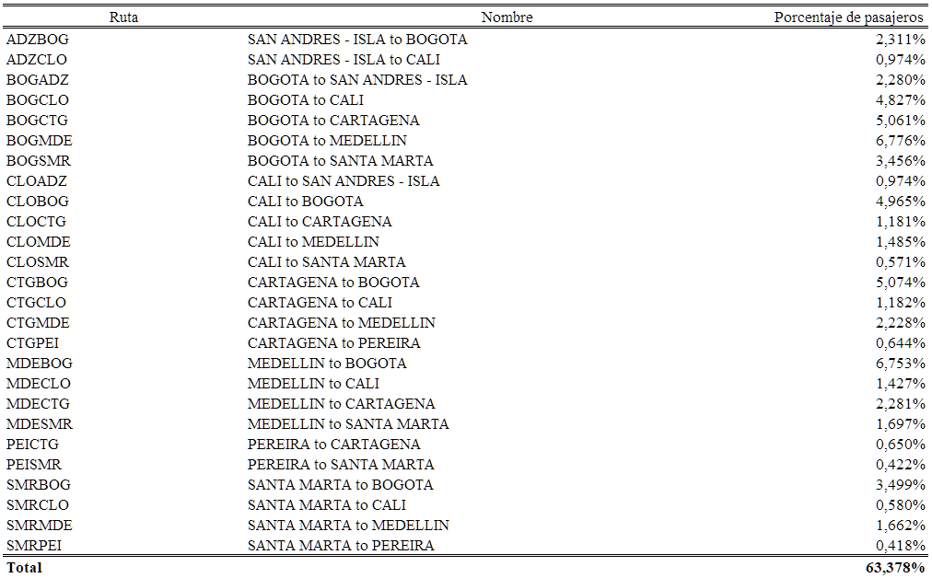

* + 1. 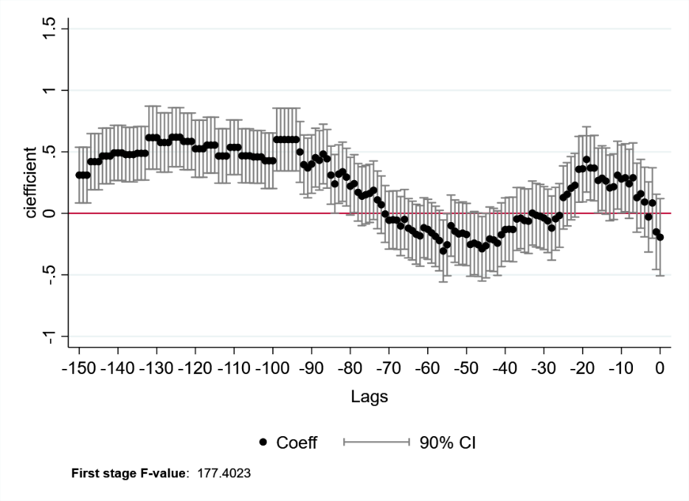Regresión Principal con FE de ruta y aerolinea
    2. Regresión Principal por Rutas y líder-seguidor con FE de ruta y aerolínea

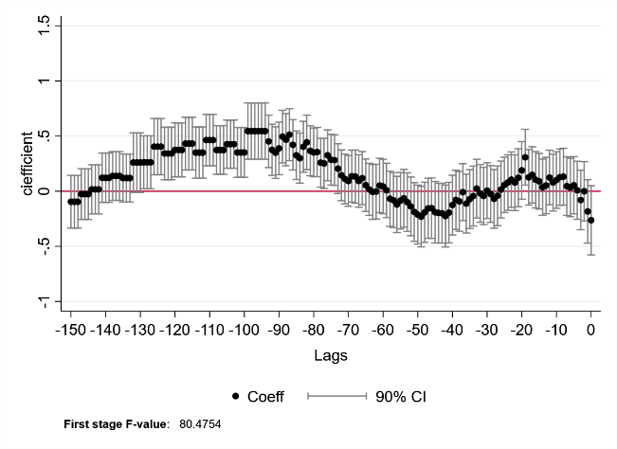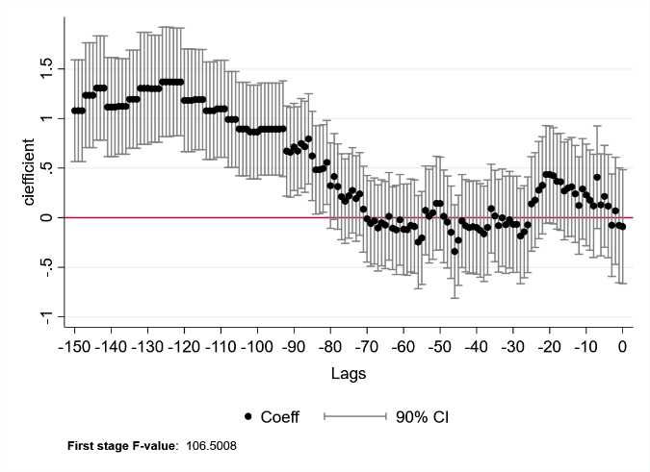 Resultados Top 30 de las rutas Resultados rutas restantes

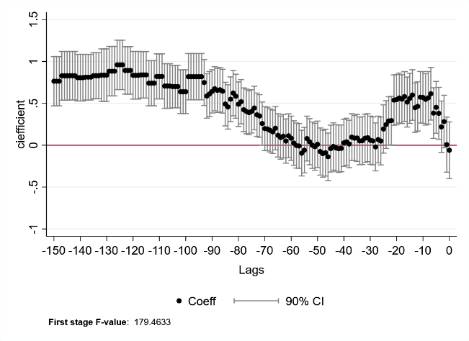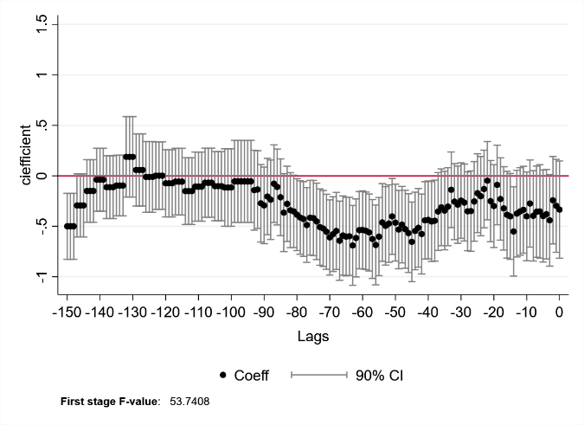 Resultados lideres Resultados seguidores

* + 1. Factor de Ocupación y ranking de principales rutas

1. Revenue Management: A strategy used by airlines to estimate demand and optimize prices (Gatti Pinheiro et al., 2022).
2. For confidentiality reasons, we cannot mention the third party.
3. Each route faces different socio-economic and cost conditions, preventing the airline from having one pricing strategy for all the routes it covers.
4. When People buy more in advance, they tend to have heterogeneous and elastic elasticities, as their trips tend to be extemporaneous. However, individuals who buy less in advance have more homogeneous and inelastic elasticities since their trips tend to be frequent and for similar reasons.
5. The number of records of the HHI is lower because it is at the route level, and the rest of the variables are at the route and airline level.
6. Indicates the number of routes, not the sum of routes in all periods.
7. The price of the airline with the higher market share will have a greater weight on the average.
8. the routes on which Ultra Air has a presence can be found in Table 1.A.5 of the appendix.
9. The pre and post-group definitions are in Table 1.A.3 and the design in 1.A.4.
10. The results of the first stage can be found in Table 1.A.4
11. We can obtain robust results at the industry level, and airline fixed effects are added in appendix 1.A.6 to measure the robustness of the main specification.
12. These groups are defined by the importance of the route, with a ranking from 1 to 74.